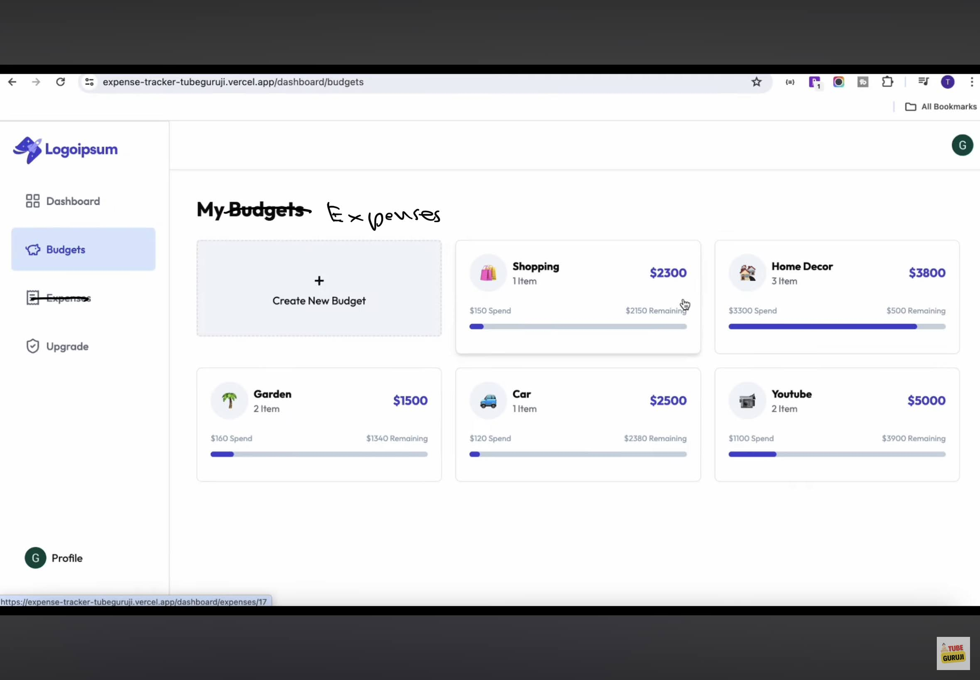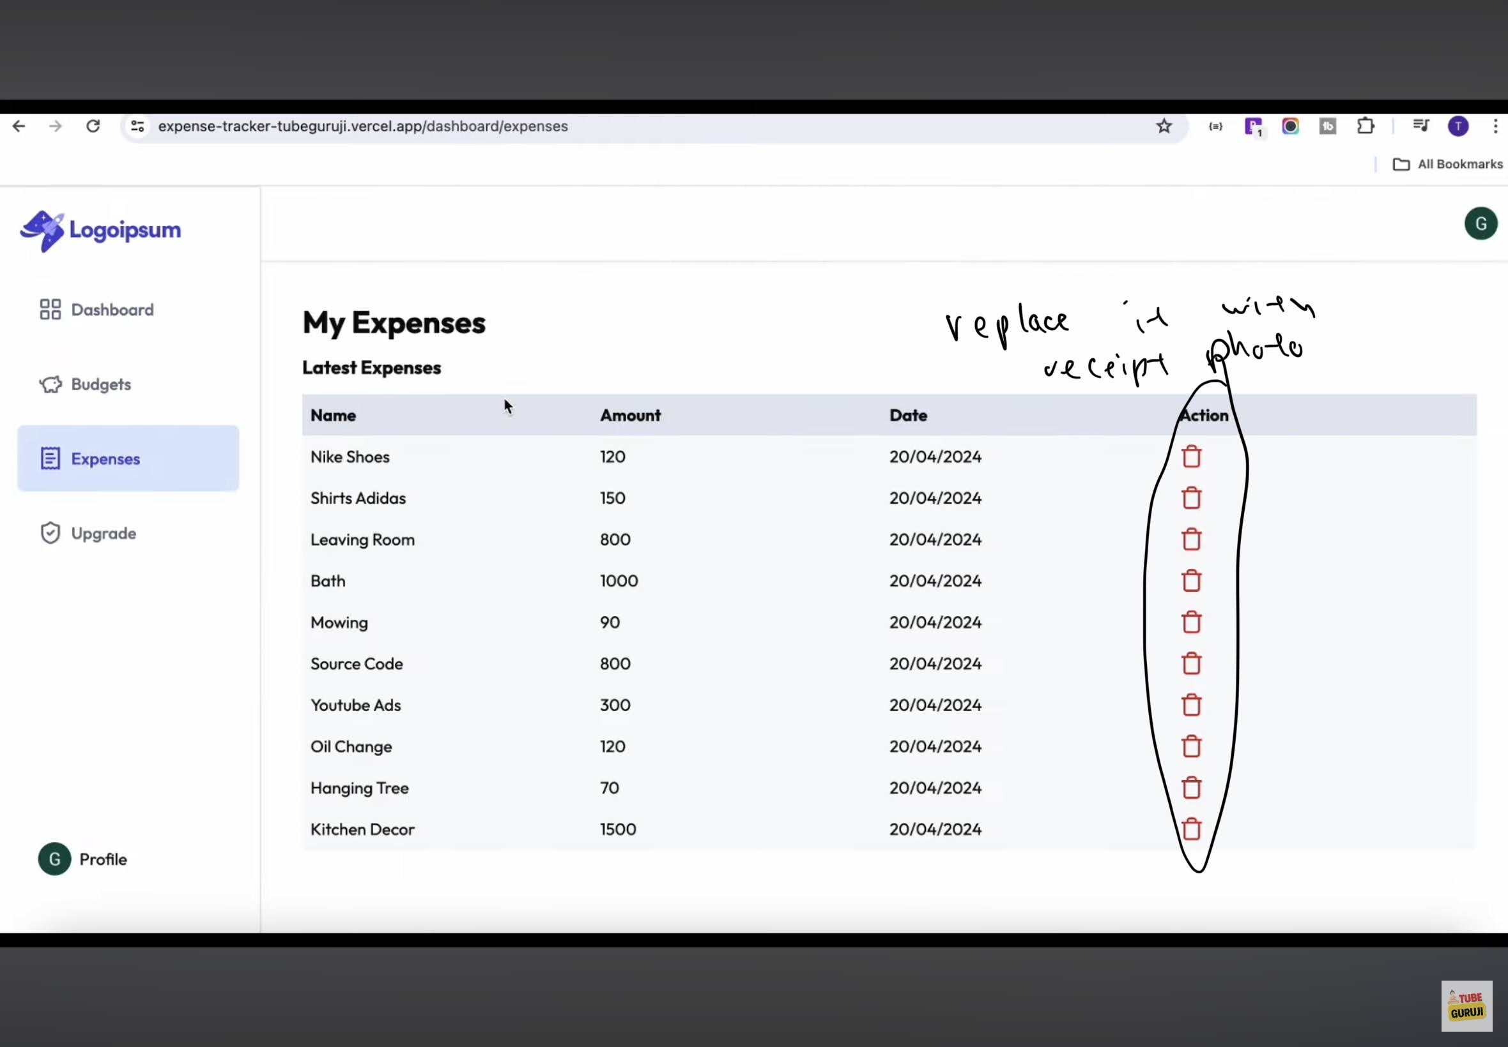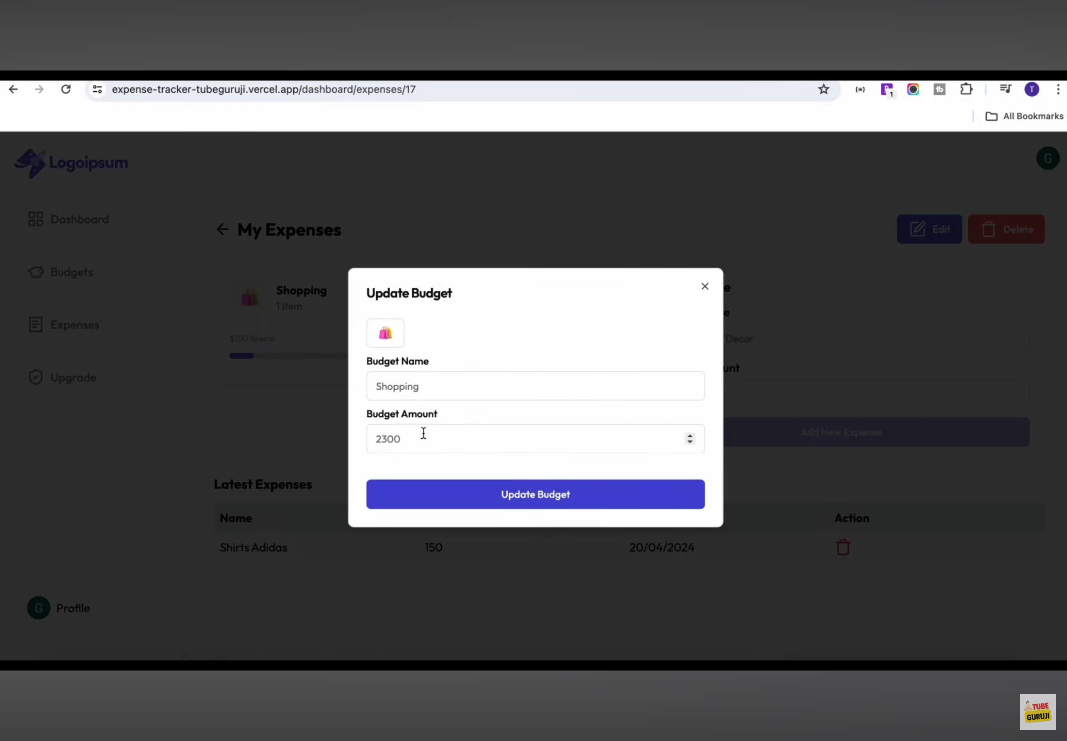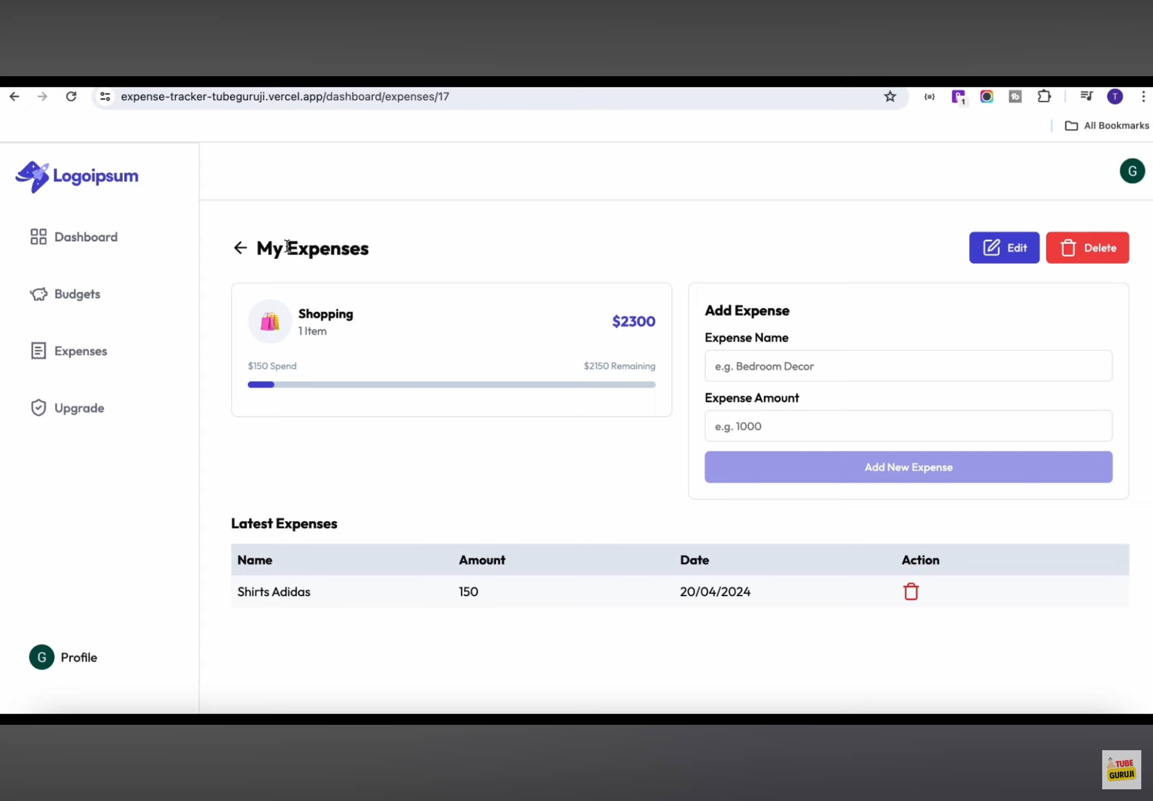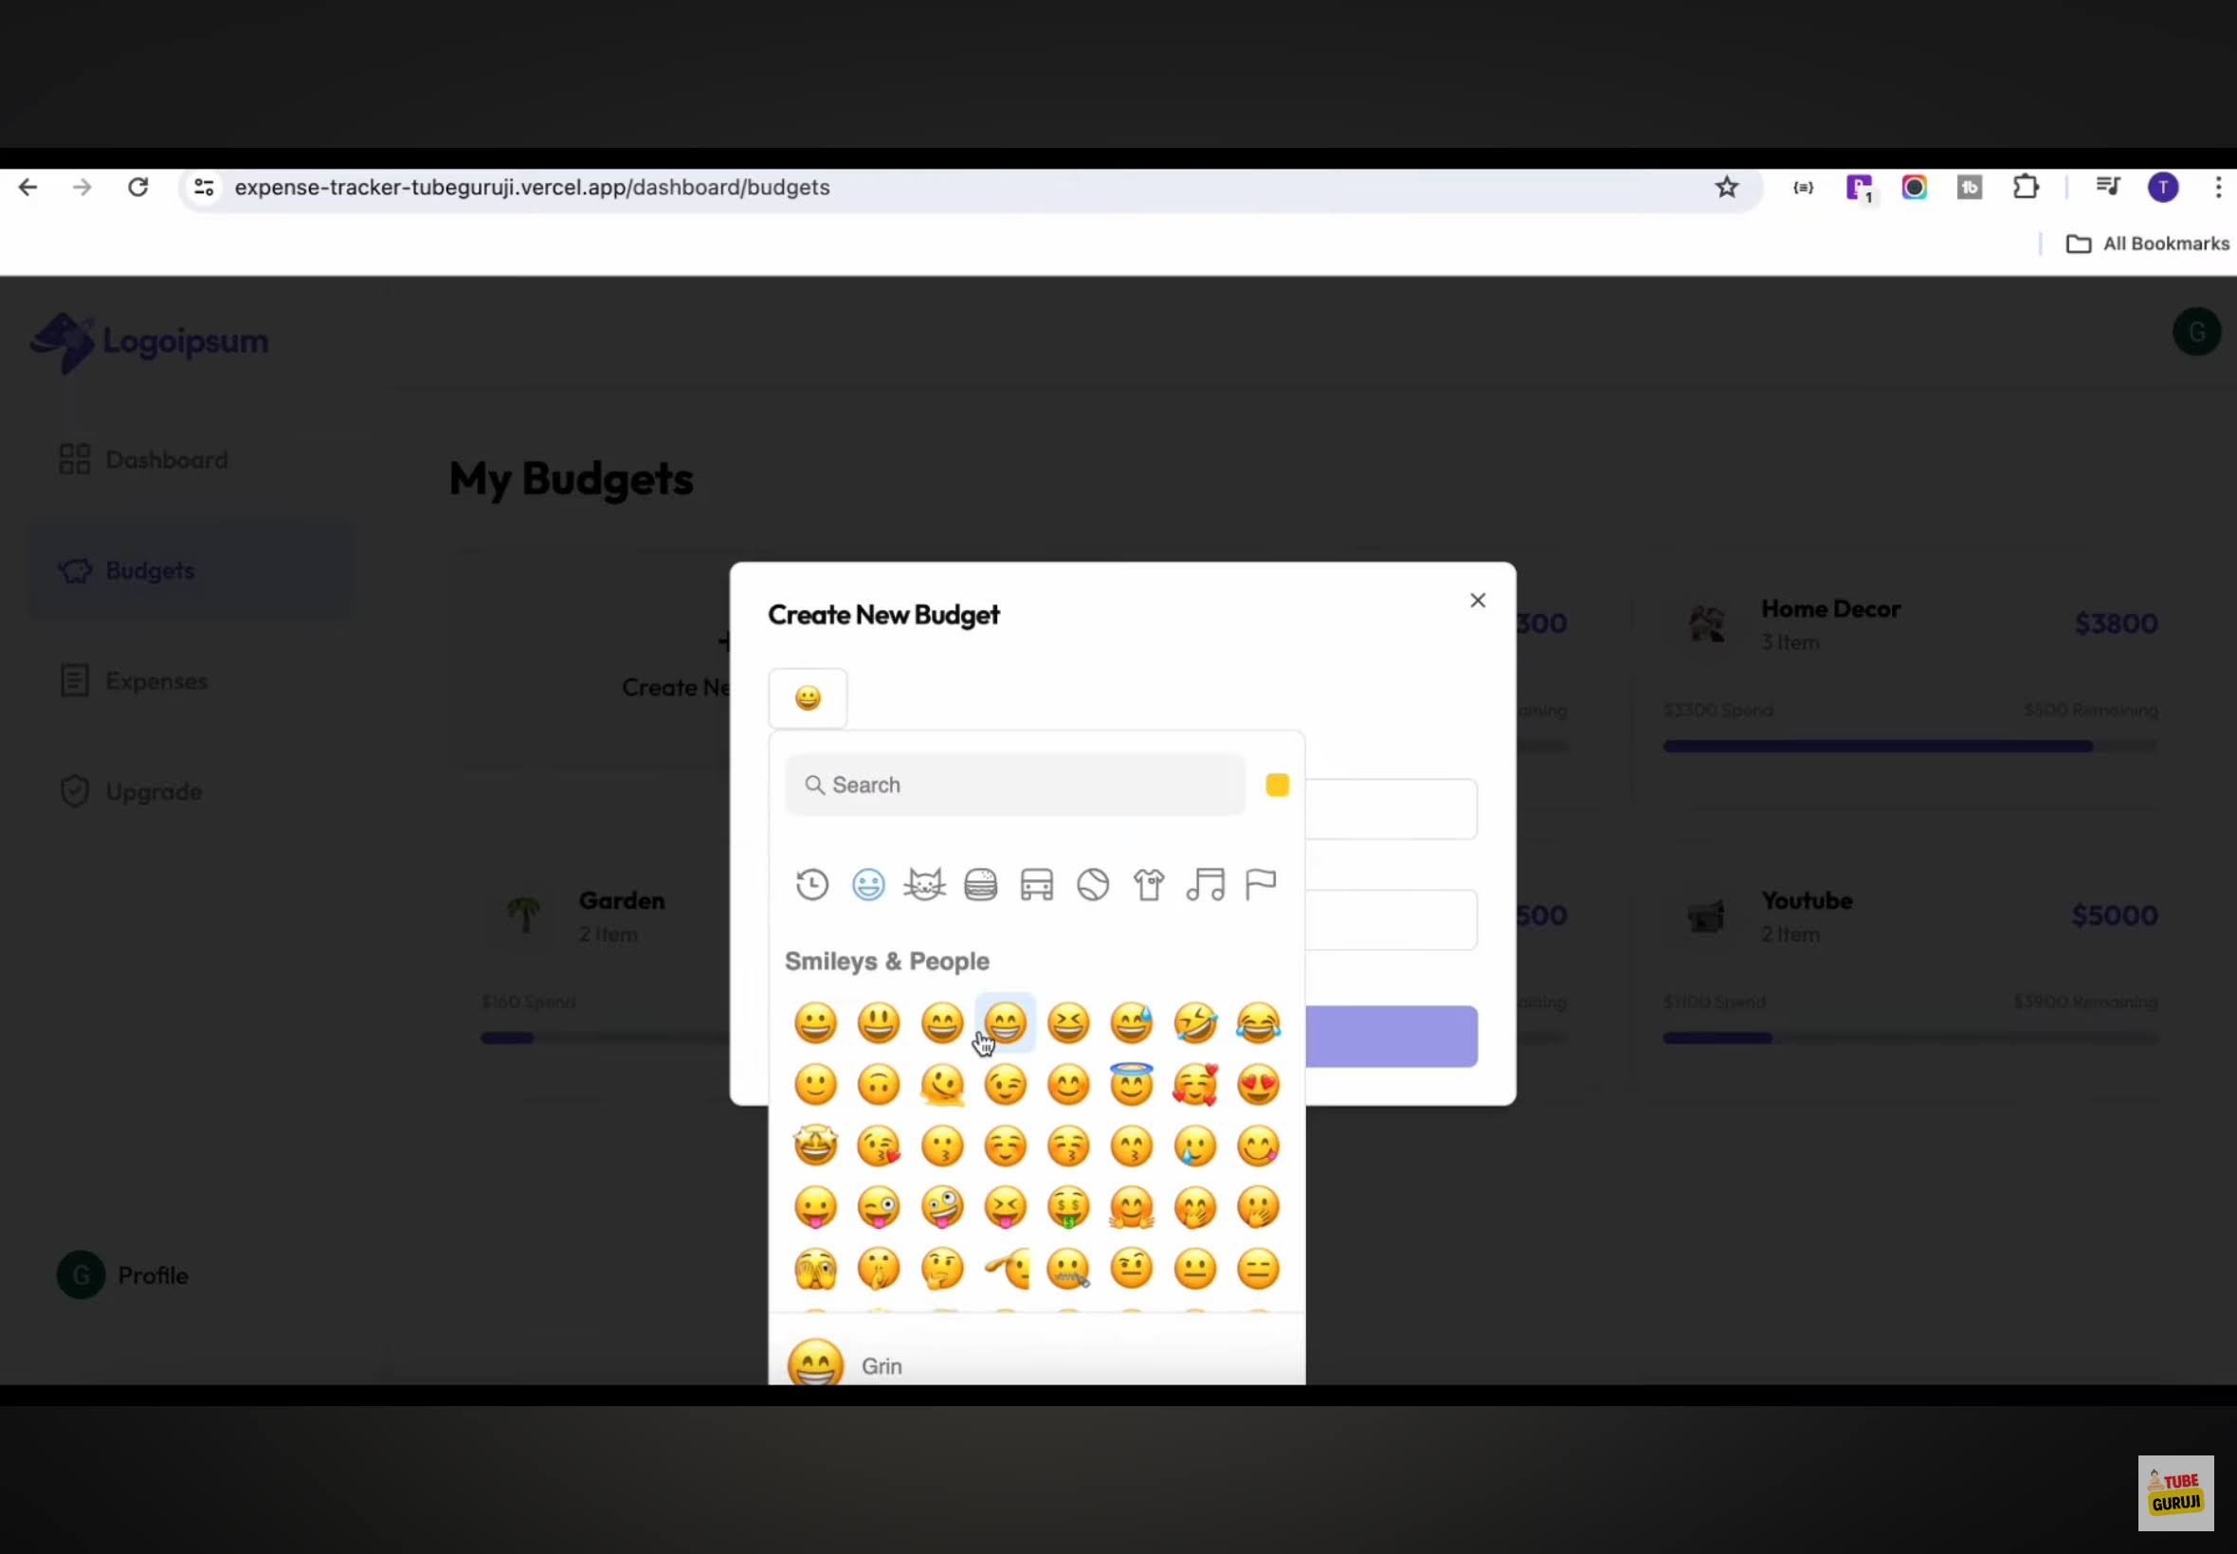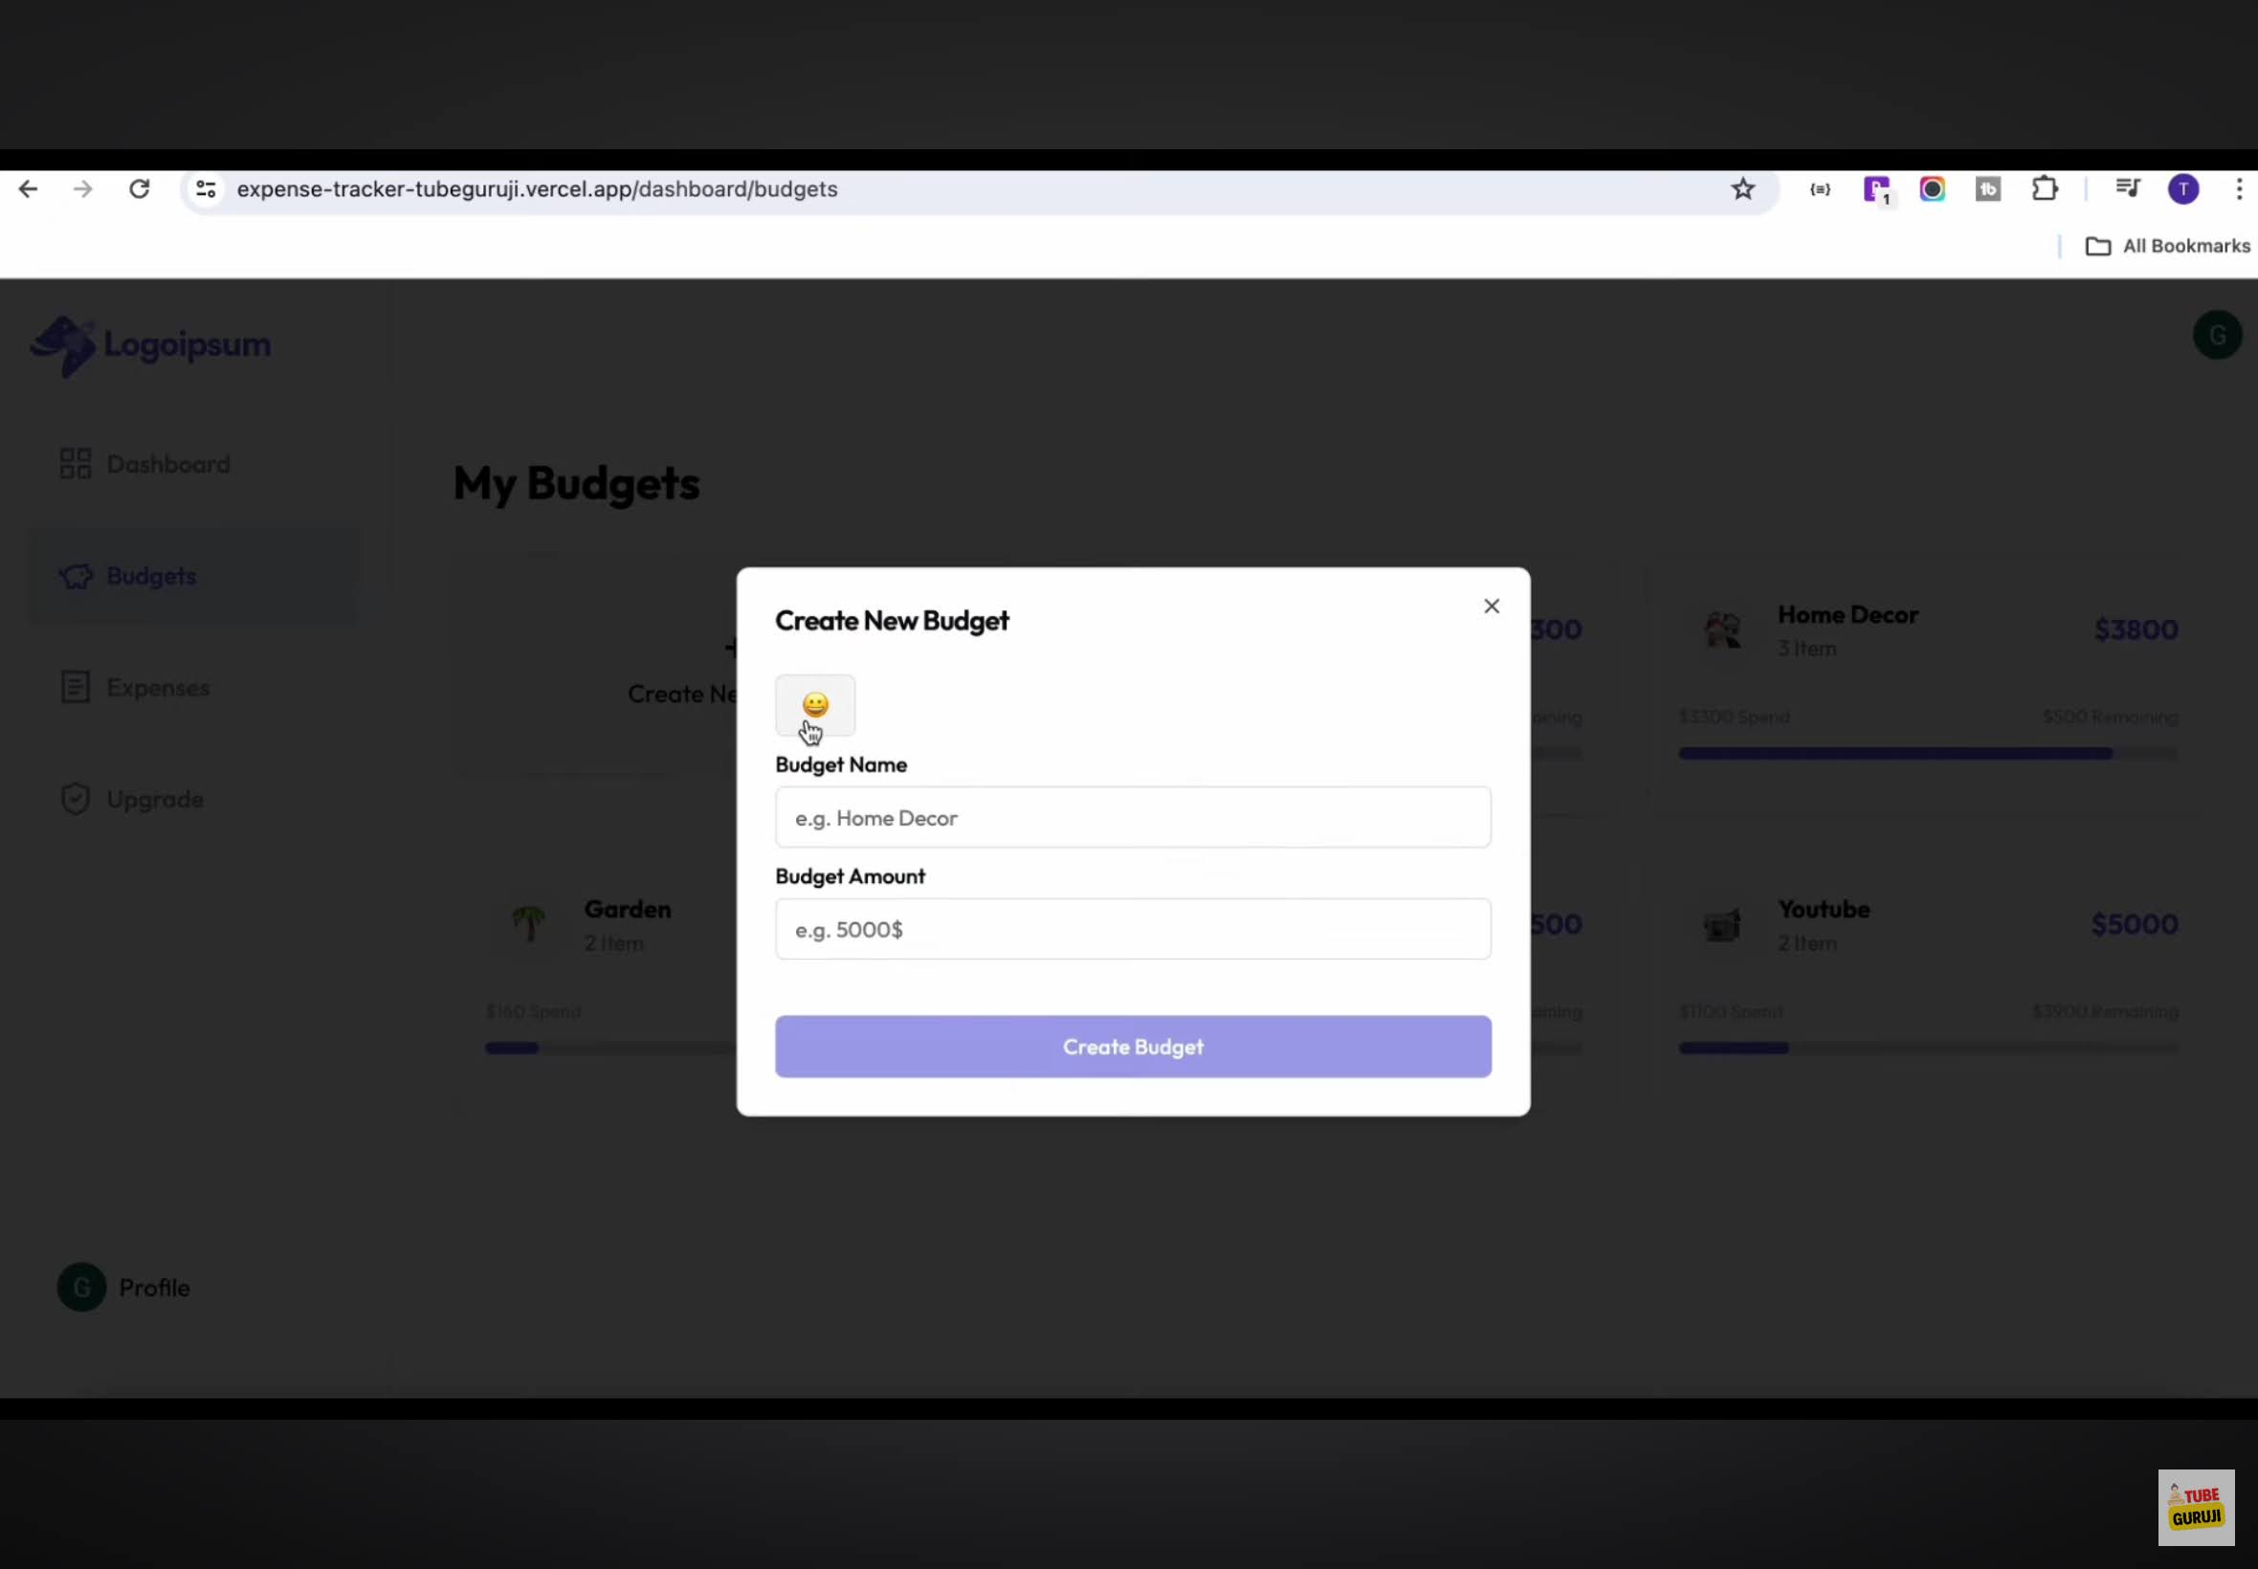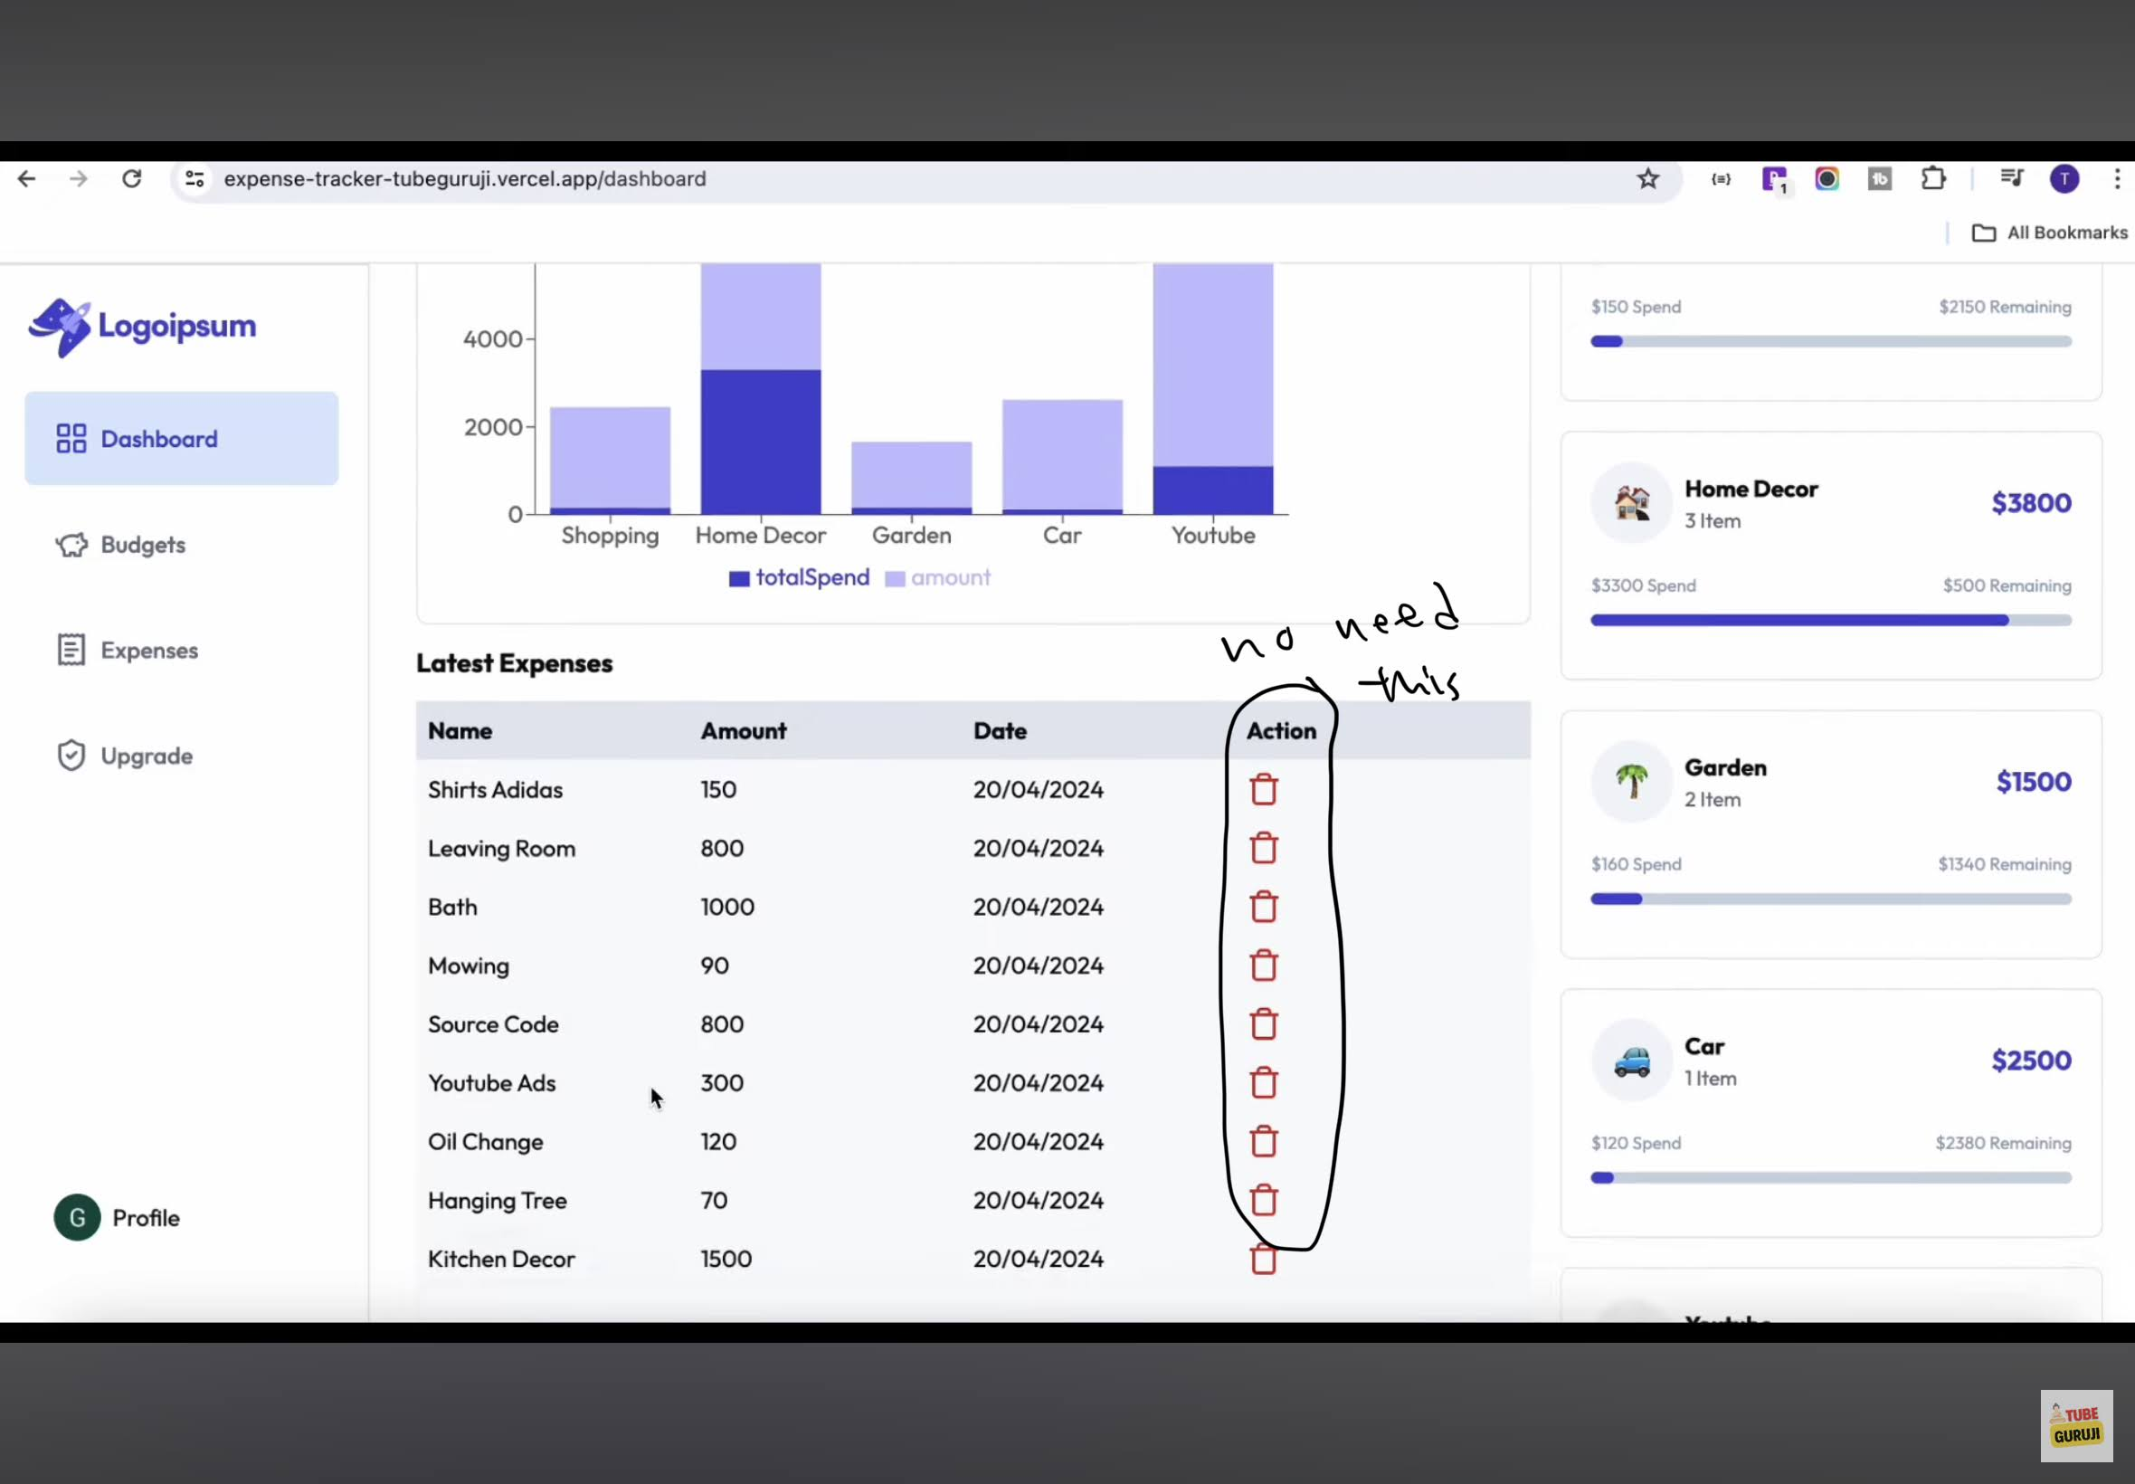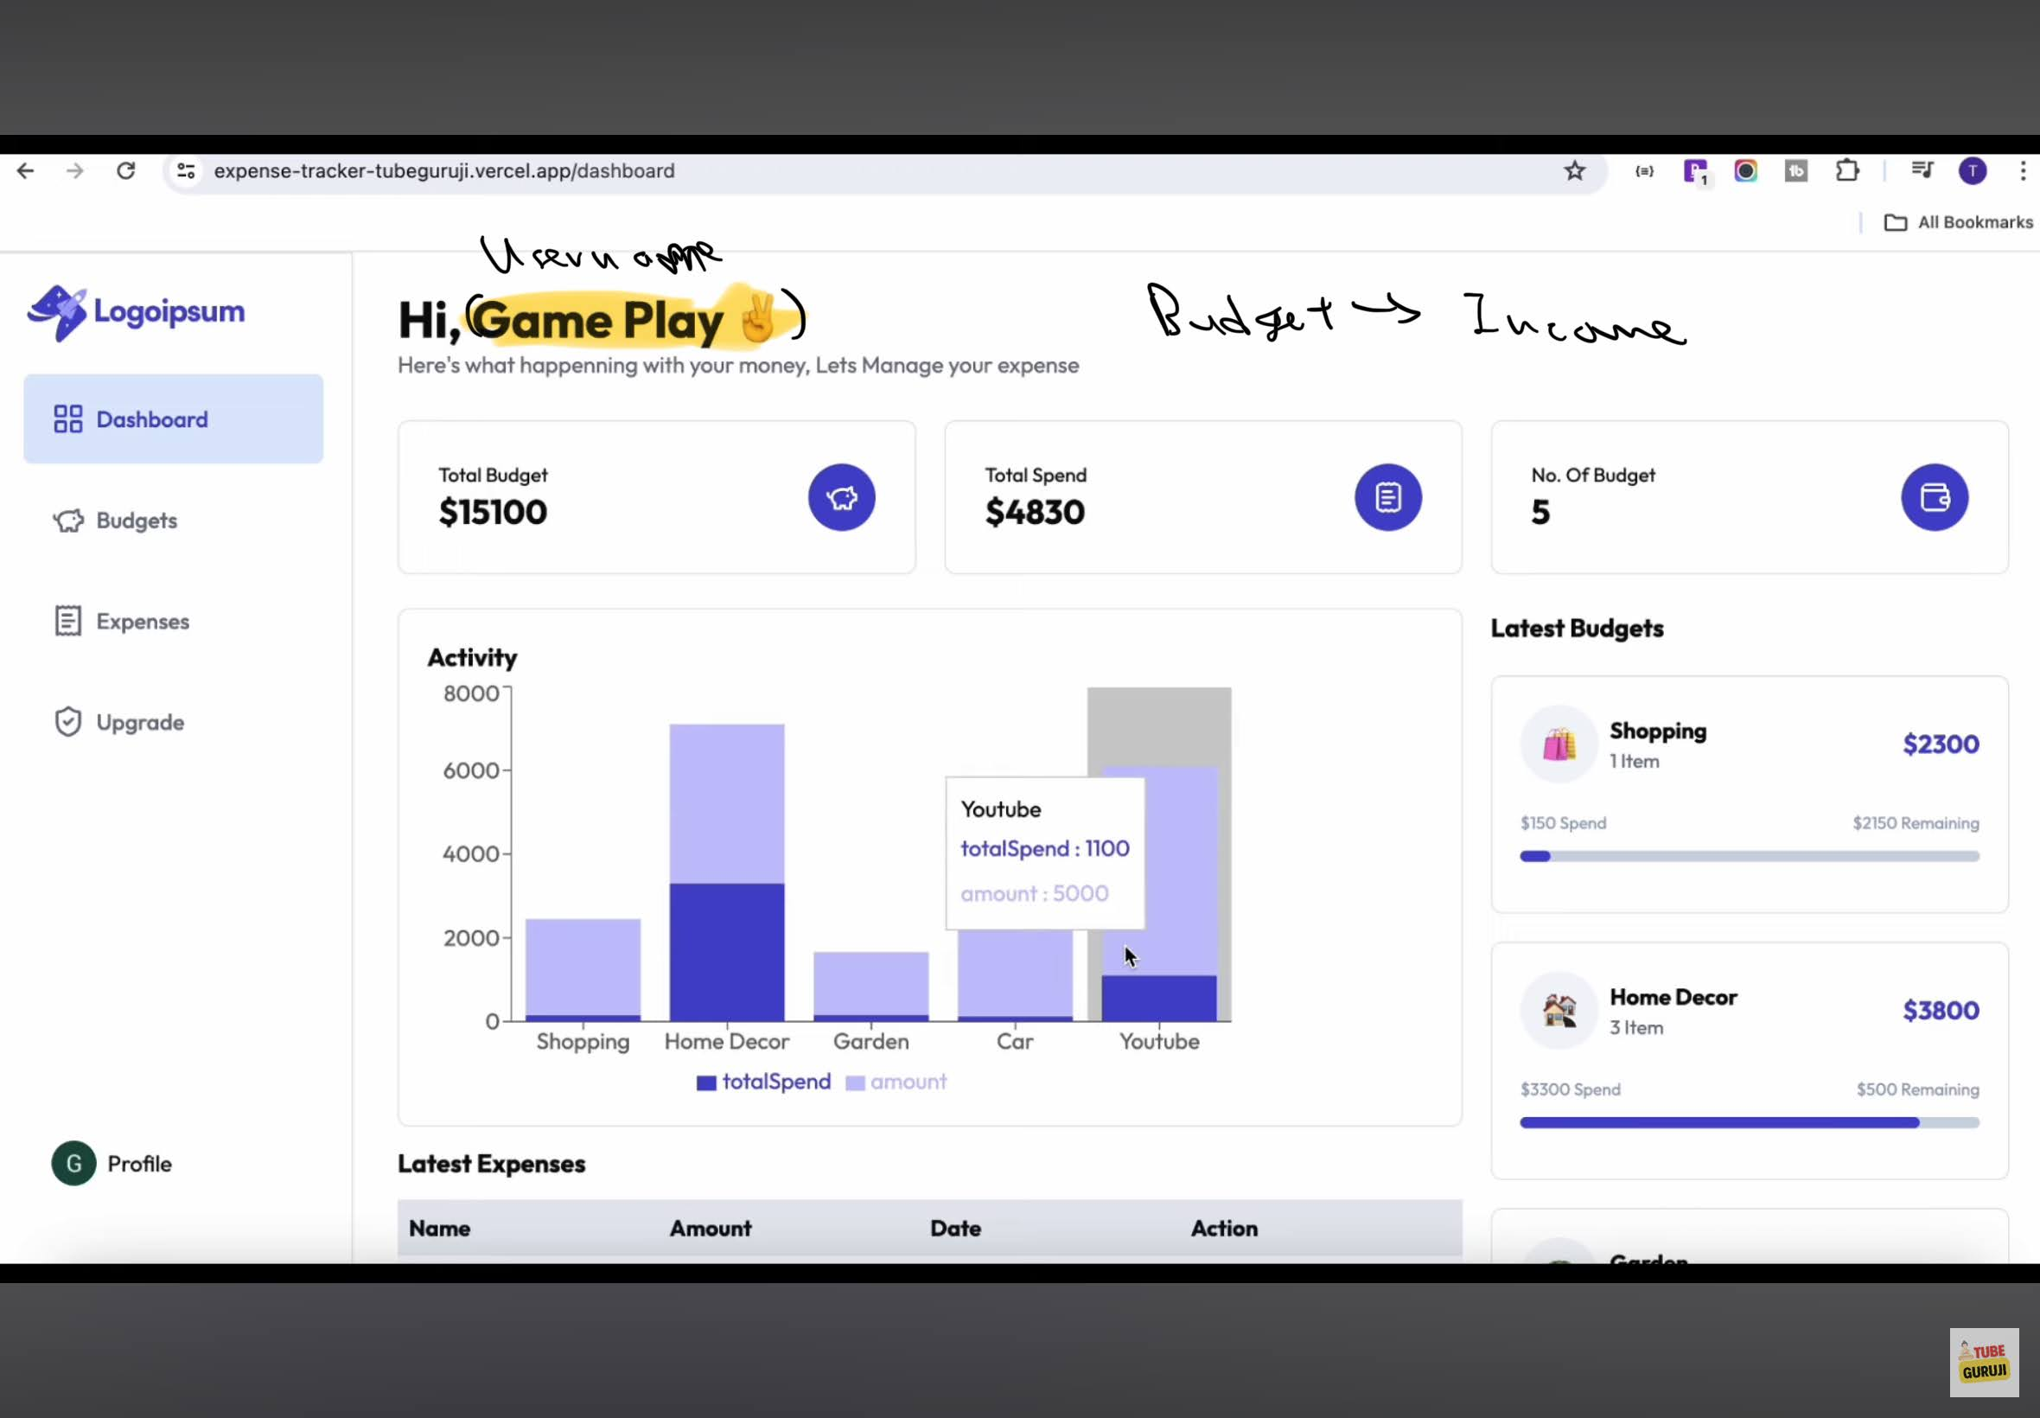

Full complete Malaysia tax deduction (tax relief) list (YA 2025)

A. Individual & spouse relief
These are basic personal deductions.
No | Category | Max relief (RM)
1 | Individual and dependent relatives | 9,000
2 | Disabled individual | 7,000
3 | Spouse (no income/joint assessment) | 4,000
4 | Disabled spouse | 6,000
5 | Alimony to former wife | 4,000
Source: Malaysia personal tax relief tables.

B. Parents relief
Support for parents qualifies:
No | Category | Max relief (RM)
6 | Medical treatment, special needs and carer expenses for parents | 8,000
7 | Parental care relief | 3,000
Source: LHDN parental relief descriptions.

C. Disabled related relief
Support for disabled persons:
No | Category | Max relief (RM)
8 | Basic supporting equipment for disabled (self/spouse/child/parent) | 6,000
9 | Disabled child | 8,000
10 | Disabled child (higher education additional) | +8,000
Source: Malaysian disability relief lists.

D. Education & self-development
Education related expenses:
No | Category | Max relief (RM)
11 | Education fees (self) | 7,000
12 | Skills improvement courses (subset of education relief) | Included
13 | SSPN education savings (net deposit) | 8,000
Source: Malaysian education tax relief rules.

E. Medical & health relief
Medical expenses for self, spouse and children:
No | Category | Max relief (RM)
14 | Serious disease treatment | Part of 10,000 cap
15 | Fertility treatment | Part of 10,000 cap
16 | Vaccination | Limited to RM1000
17 | Dental treatment | Limited to RM1000
18 | Mental health treatment | Limited to RM1000
19 | Medical check-up | 1,000 sublimit
20 | Child learning disability treatment | 6,000
Combined medical cap typically RM10,000.
Source: Medical relief categories.

F. Children related relief
Child related deductions:
No | Category | Max relief (RM)
21 | Child under 18 | 2,000 per child
22 | Child 18+ (pre-university) | 2,000
23 | Child 18+ higher education | 8,000
24 | Childcare fees | 3,000
25 | Breastfeeding equipment | 1,000
Source: Child relief tables.

G. Lifestyle & sports
General lifestyle deductions:
No | Category | Max relief (RM)
26 | Lifestyle purchases (books, PC, phone, internet) | 2,500
27 | Sports equipment & activities | 1,000
28 | EV charging equipment | 2,500
Source: Lifestyle relief categories.

H. Insurance & retirement
Financial protection deductions:
No | Category | Max relief (RM)
29 | EPF contributions | 4,000
30 | Life insurance | 3,000
31 | Education & medical insurance | 4,000
32 | SOCSO | 350
33 | Private Retirement Scheme (PRS) | 3,000
34 | Deferred annuity | Same with PRS
Source: Insurance and retirement relief lists.

I. Housing relief
Housing related tax relief:
No | Category | Max relief (RM)
35 | First home housing loan interest | 5,000–7,000

